SPORTS TEAM MANAGEMENT SYSTEM

STEP1: CREATING DATABASE

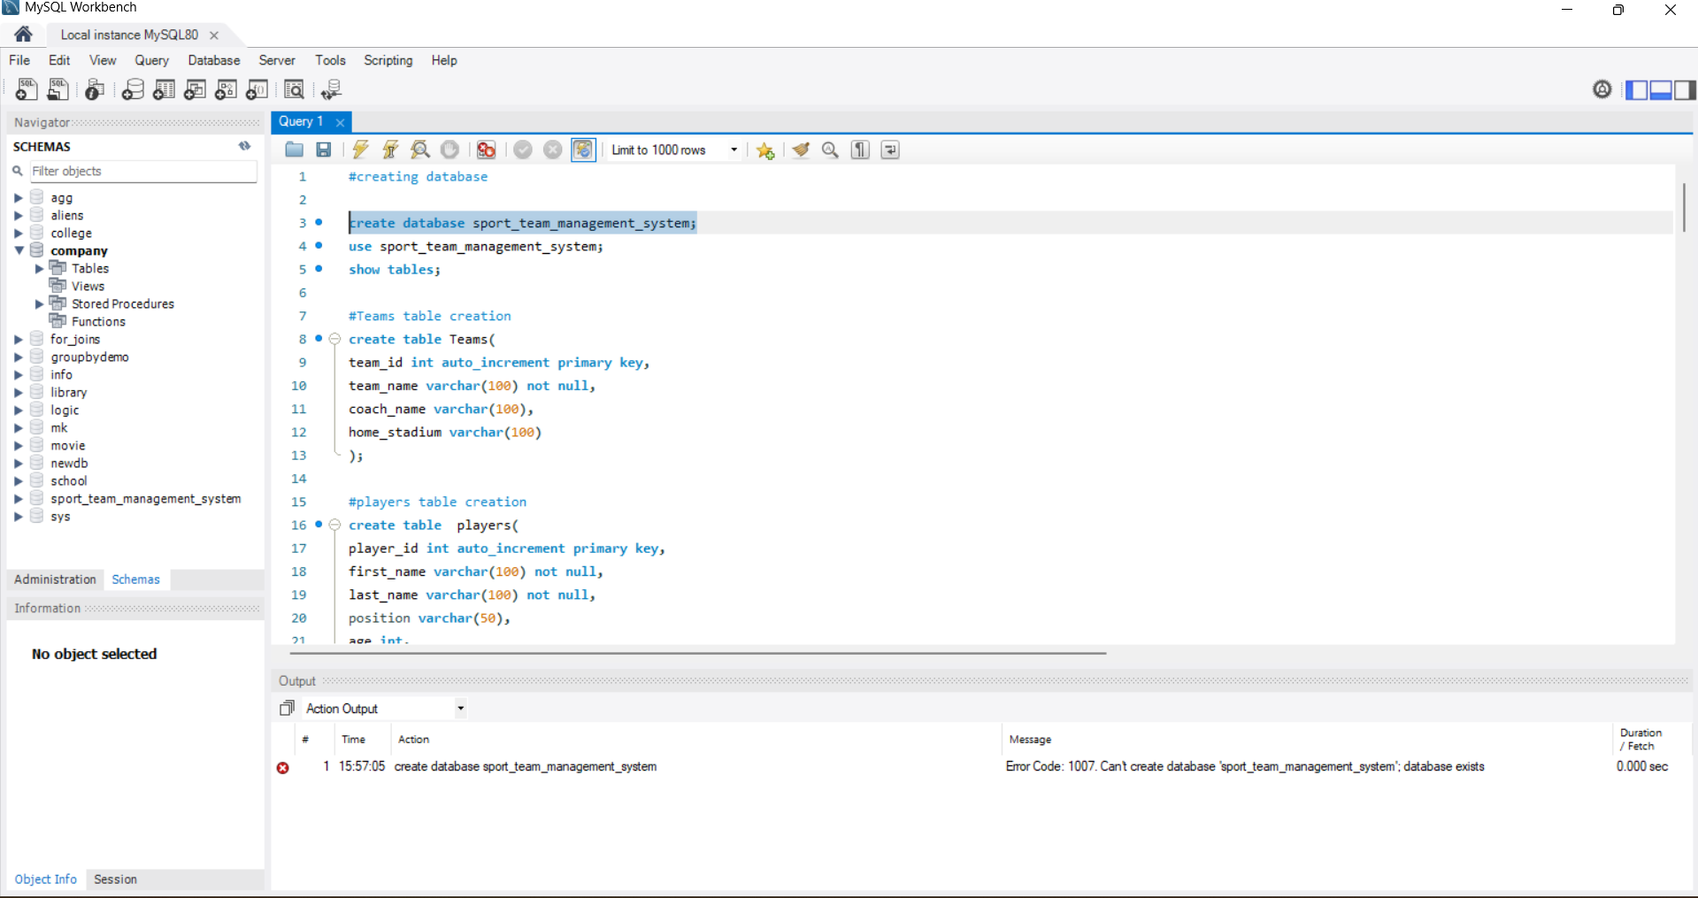

STEP2: CREATE TABLE TEAMS

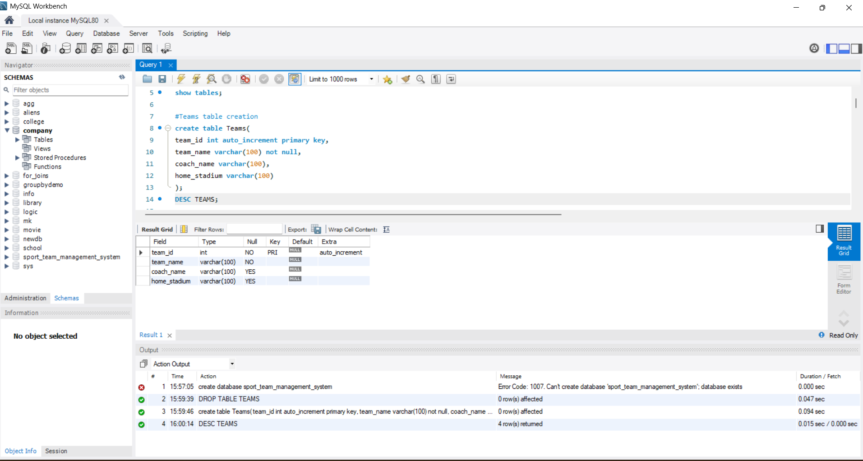

STEP3: CREATE TABLE PLAYERS

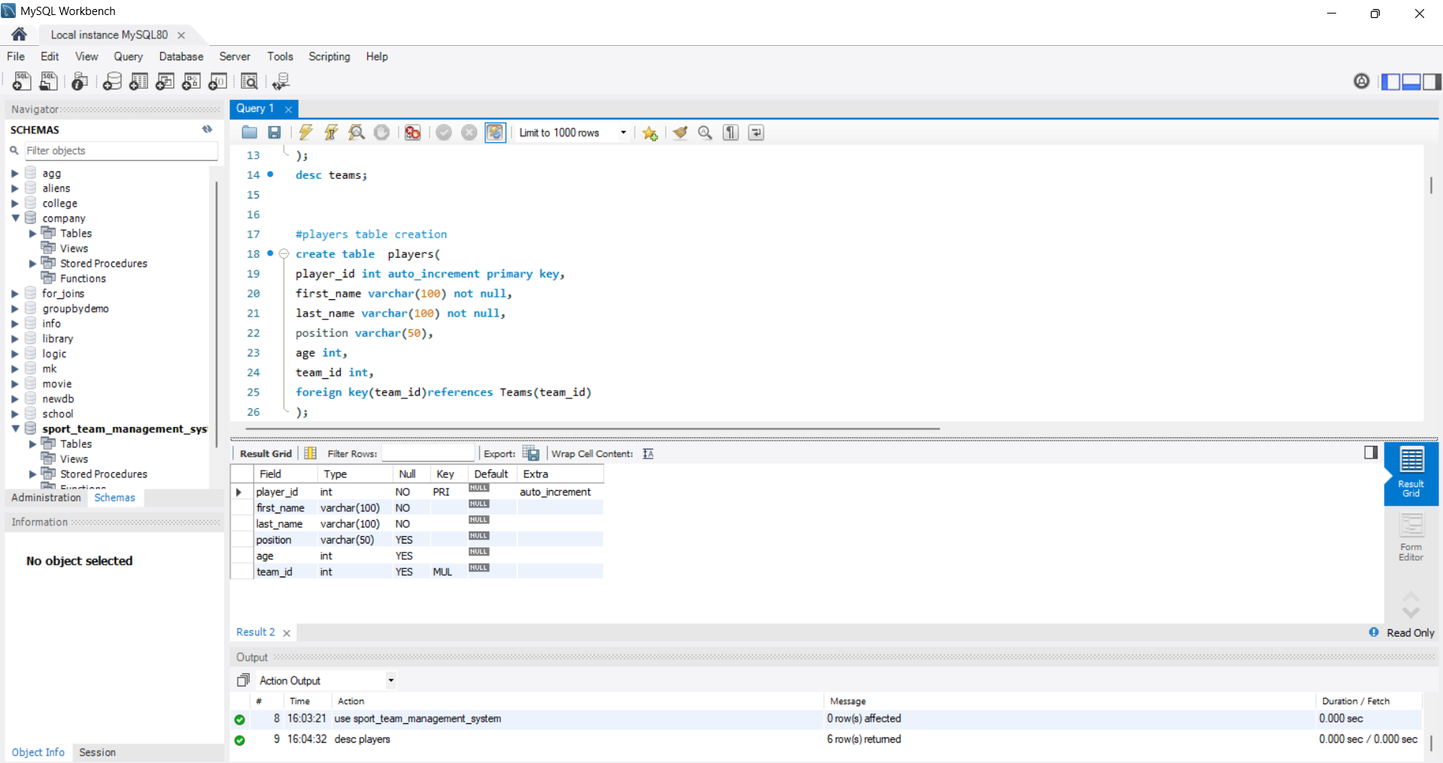

STEP4: CREATE TABLE LEAGUES

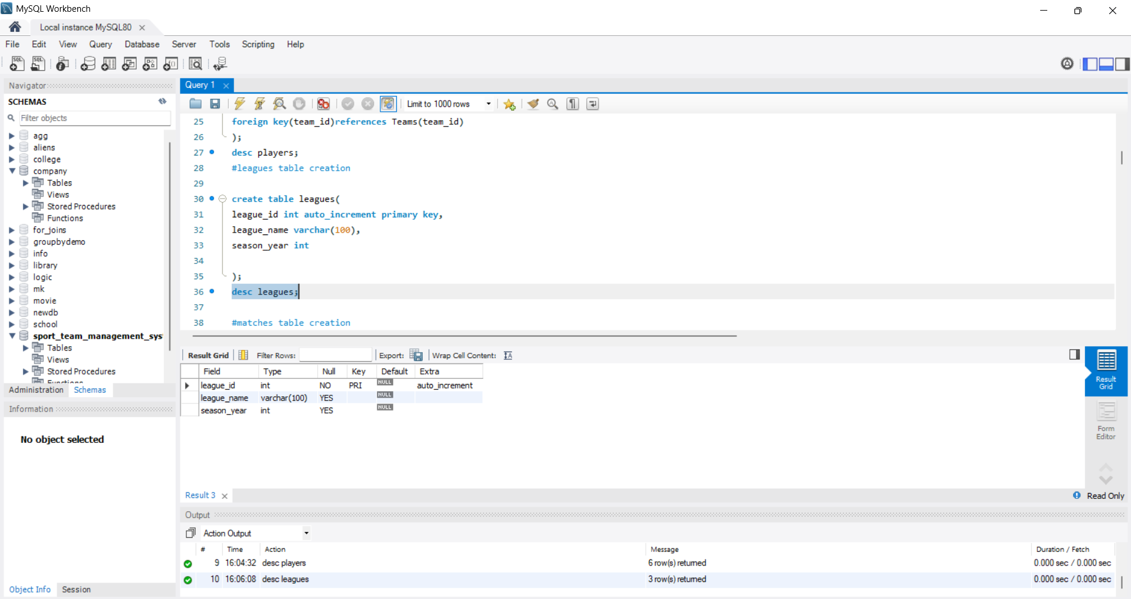

STEP5: CREATE TABLE MATCHES

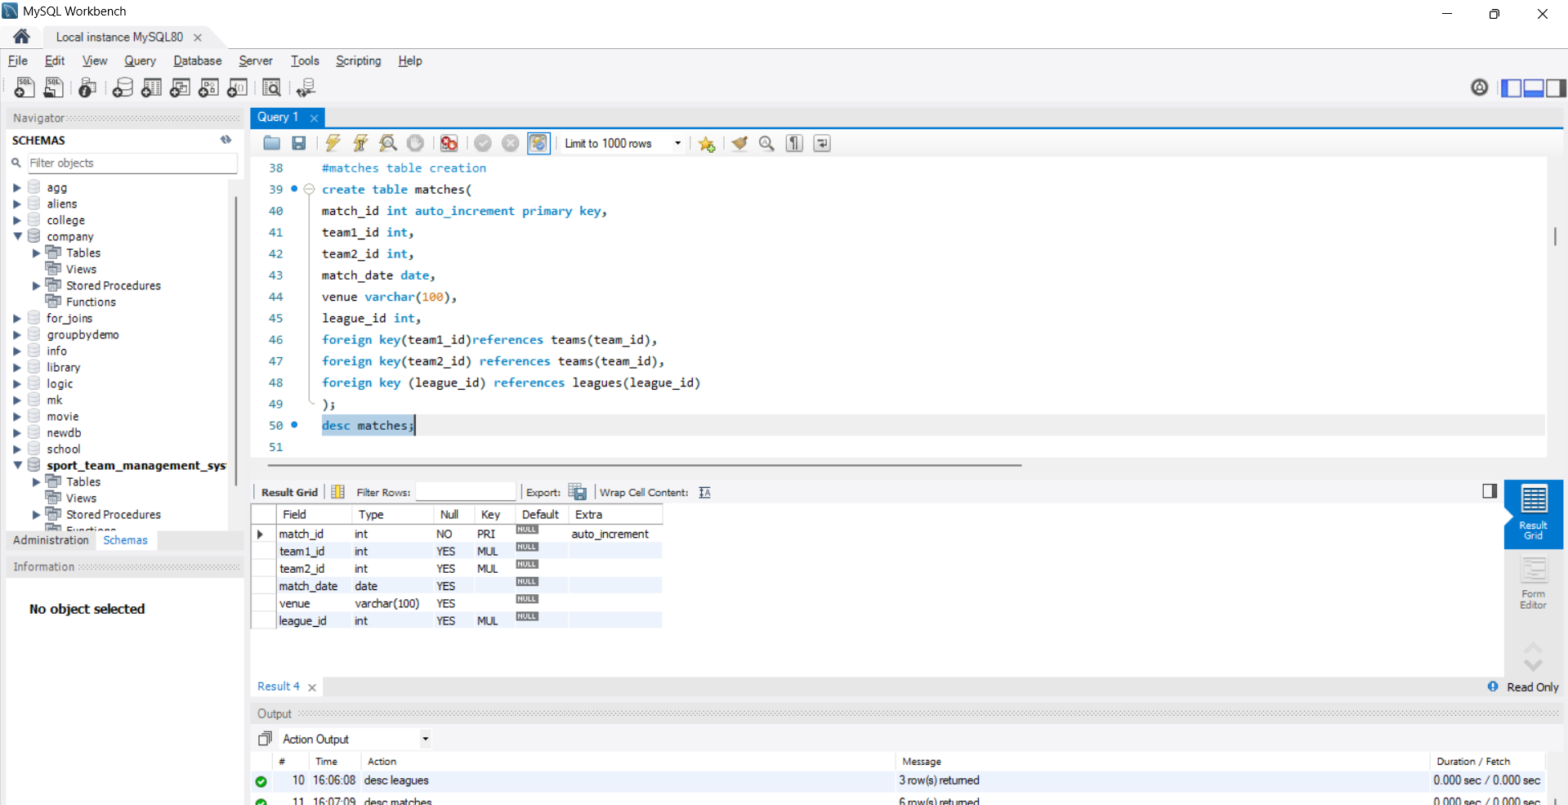

STEP6:CREATE TABLE SCORES

